**Automatic room name-matching in cloud server**

**Open the link with browser,** [**http://3.25.255.194:50000/**](http://3.25.255.194:50000/)

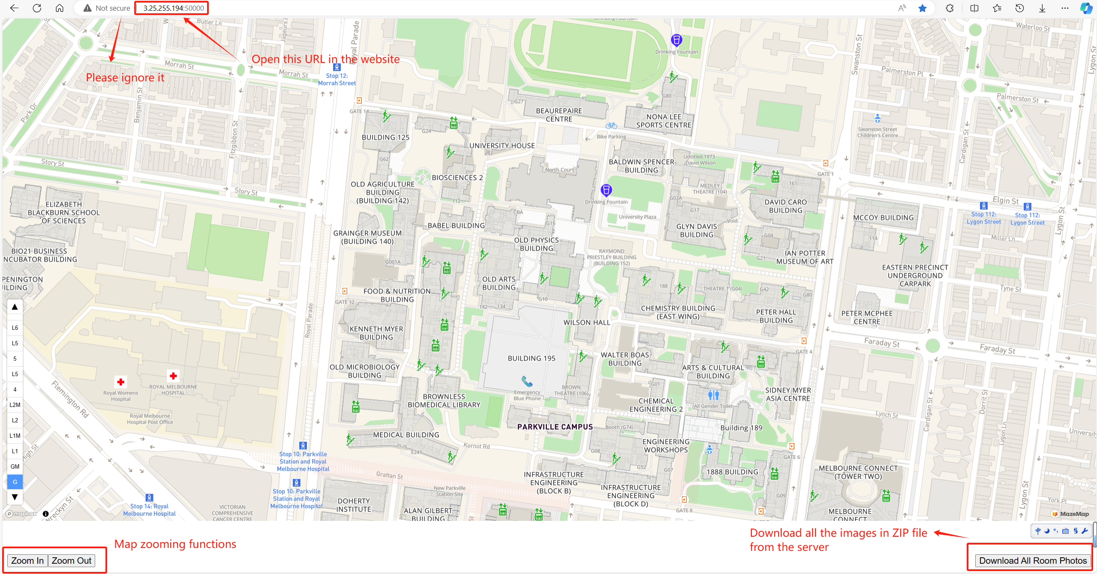

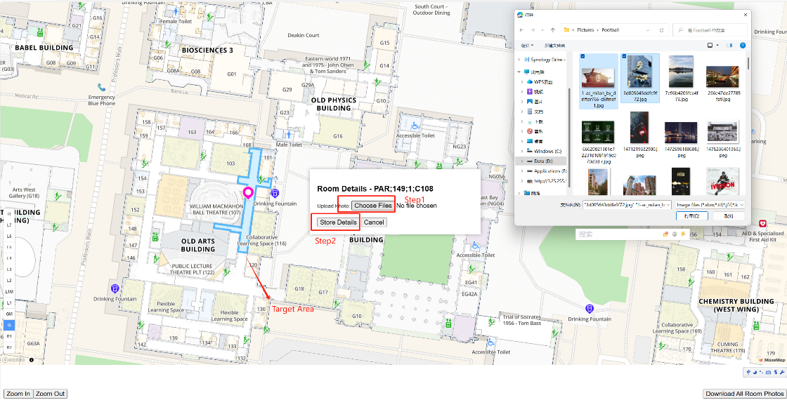**Choose the target room**

**Check the result**

**System Structure**

Ubuntu 22.04.3 LTS (Jammy Jellyfish) x86_64(Py3.7.8)

Intel(R) Xeon(R) CPU E5-2676 v3 @ 2.40GHz * 1 Html + CSS + PHP

**Q&A:**

* **My browser pop-up a warning?**

Please ignore it because I did not use the SSL encryption

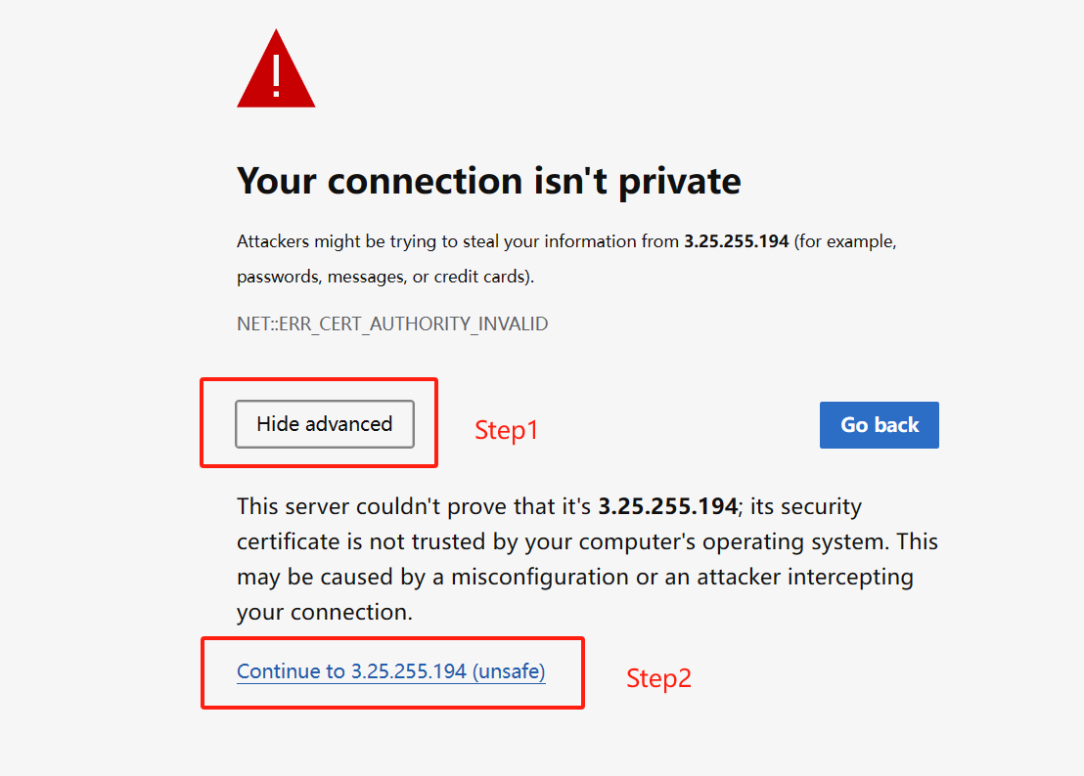

* **How about the cost?**

I get a free access to EC2 for 12 months, starting when I signed up for an AWS account.



* **Is this system stable?**

In my tests, I didn't experience upload failures

* **I want to deploy in my server?**

First of all, the server will have an IP address and open a port number (e.g. 50000) for the service, and 1024 to 65535 will be dynamic or private port numbers for general applications. Put the existing project files into the directory and use IP + Port to access the service

(e.g., <http://3.25.255.194:50000/> )

* **My pictures are large, will it be a burden on the server?**

Yes, the server will resize the photo to less than 1mb per picture. And PNG format photos are using more time due to the convention to the PIC format.